STATE OF WASHINGTON
STATE BUILDING CODE COUNCIL

15-009

State Building Code to be Amended:
International Building Code State Energy Code
ICC ANSI A117.1 Accessibility Code International Mechanical Code International Existing Building Code International Fuel Gas Code International Residential Code NFPA 54 National Fuel Gas Code
International Fire Code NFPA 58 Liquefied Petroleum Gas Code
Uniform Plumbing Code Wildland Urban Interface Code

Section(s): Section 907
Title:
Fire Alarm and Detection Systems

Proponent Name (Specific local government, organization or individual): Proponent: Mike Six
Title: Fire Marshal, City of Bremerton Date: February 21, 2015

- Designated Contact Person: Name: Mike Six
Title: Fire Marshal, City of Bremerton Address: 911 Park Ave

Office Phone: 360.473.5386
Cell: 360.434.6406
E-Mail address: Michael.Six@ci.bremerton.wa.us

February 21, 2015

- Proposed Code Amendment. Reproduce the section to be amended by underlining all added language, striking through all deleted language. Insert new sections in the appropriate place in the code in order to continue the established numbering system of the code. If more than one section is proposed for amendment or more than one page is needed for reproducing the affected section of the code additional pages may be attached. (Examples on the SBCC website)

Code(s) 907.8

Section(s) International Fire Code Section 907 International Building Code Section 907

The maintenance and testing schedules and procedures for the fire alarm and fire detection shall be in accordance with sections 907.8.7 through 907.8.5 and NFPA 72. Records of inspection, testing maintenance shall be maintained in a red 3” three ring binder affixed to the wall in a file holder near the primary fire alarm panel. Persons performing inspection, testing, programming and other maintenance, not considered “electrical work” by RCW 19.28 shall be completed by persons NICET II, in fire alarms, certified. When inspection, testing, programming and maintenance requires more than one technician at least 50% of the technicians shall be NICET II certified.

Enforceable code language must be used; see an example by clicking here. Amend section to read as follows:

- Briefly explain your proposed amendment, including the purpose, benefits and problems addressed. Specifically note any impacts or benefits to business, and specify construction types, industries and services that would be affected. Finally, please note any potential impact on enforcement such as special reporting requirements or additional inspections required.

The intent of the proposed code amendment is to improve both the quality of the inspection and testing. As with the proposal for NICET III for design, the system is only as good as it is maintained. This proposal helps to ensure only qualified technicians are performing these vital tasks.

There is currently no performance standards or other requirements for a technician to perform these vital functions on life safety systems.

I included the same justification for the NICET III proposal:
The problems that have been created by the irresponsible installation of fire alarm system has created a number of problems.
- False alarms trains’ people to ignore the fire alarm system. When the community does not respect the fire alarm sounding we have lost the entire purpose of active fire protection systems. Early notification is a bedrock principal in fire protection. When the fire alarm is ignored we lose the advantage of early notification.
- False alarms also create a burden to fire departments. Each one of these false alarms has be fire unit responding to check the property and the alarm. Although often times these are not overly time consuming responses, each one requires a written report and distracts from other emergency responses.
- It is not uncommon for injuries to the occupants to occur during the evacuation process. The occupants of any complex put themselves at risk when they evacuate a structure. When age and mobility are considered compounded by time of day and visibility the possibility for injuries increases.

The proposal for a NICET II performing inspection, testing and maintenance is the vital factor for the success of the fire alarm system. If the system simply doesn’t work, what’s the point? NICET has a system of recertification, CME required and an ETHICS policy. If a situation develops which may require oversight, NICET will investigate and review the situation. This provides a neutral third party review of the technician’s performance.

- Specify what criteria this proposal meets. You may select more than one. The amendment is needed to address a critical life/safety need.
The amendment is needed to address a specific state policy or statute. The amendment is needed for consistency with state or federal regulations. The amendment is needed to address a unique character of the state.
The amendment corrects errors and omissions.

- Is there an economic impact: Yes No Explain:

If there is an economic impact, use the Table below to estimate the costs and savings of the proposal on construction practices, users and/or the public, the enforcement community, and operation and maintenance. If preferred, you may submit an alternate cost benefit analysis.

Building Type | Construction1 |  | Enforcement2 |  | Operations & Maintenance3
 | Costs | Benefits4 | Costs | Benefits4 | Costs | Benefits4
Residential | N/A | N/A | N/A | N/A | N/A | N/A
Single family | N/A | N/A | N/A | N/A | N/A | N/A
Multi-family | Minimal | Minimal | Minimal | Minimal | Minimal | Minimal
Commercial/Retail | Minimal | Minimal | Minimal | Minimal | Minimal | Minimal
Industrial | Minimal | Minimal | Minimal | Minimal | Minimal | Minimal
Institutional | Minimal | Minimal | Minimal | Minimal | Minimal | Minimal

1 $ / square foot of floor area or other cost. Attach data. Construction costs are costs prior to occupancy, and include both design and direct construction costs that impact the total cost of the construction to the owner/consumer.

2 Cost per project plan. Attach data. Enforcement costs include governmental review of plans, field inspection, and other action required for enforcement.

3 Cost to building owner/tenants over the life of the project.

4 Measurable benefit.

As with the NICET III proposal, the NICET II will be nearly impossible to calculate. Below are the costs for certification. Of course there are code books and other testing costs, but overall limited in the big picture.

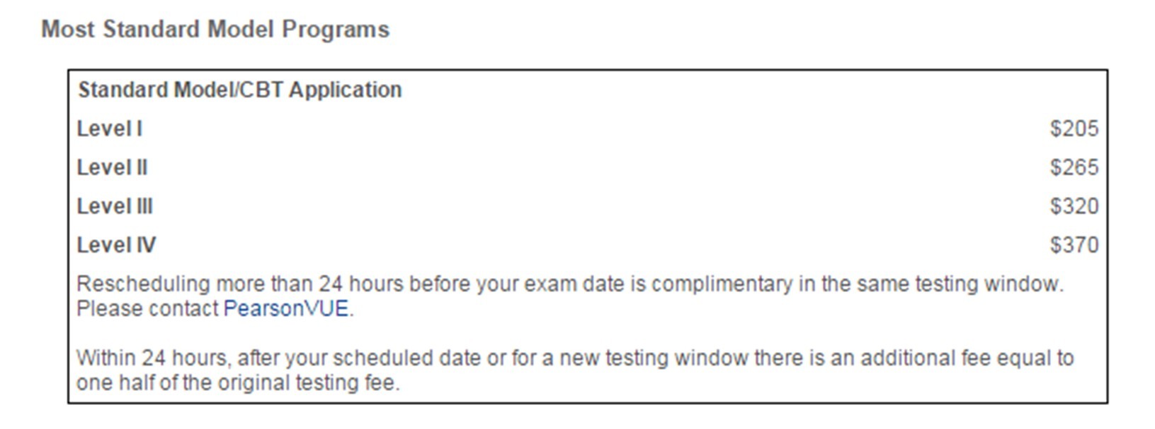

Please send your completed proposal to: sbcc@ga.wa.gov
All questions must be answered to be considered complete. Incomplete proposals will not be accepted.

