January 8, 2015

State Building Code Council
P.O. Box 41449
Olympia, WA 98504

Dear State Building Code Council,
RECEIVED

IbN 15 1015

Mike Allen
) Counci l Member District 2

Please see the attached resolution that was voted on unanimously by the Spokane City Council on December 1, 2014 in favor of my proposed amendment to International Residential Code, Section R101.2 regarding sprinkler installation in owner occupied lodging homes. I will be resubmitting my code amendment by the March 2015 deadline for consideration.

;44-

Councilmember Mike Allen

. .

RESOLUTION N0.2014-0106

A resolution regarding an emergency application to the Washington State Building Code Council regarding an amendment to the International Residential Building Code relating to construction of owner-occupied lodging homes.

WHEREAS, over the past several months, the City of Spokane, as well many local jurisdictions around the county, have been working on addressing the emerging short term rental industry referred to as Airbnb, VIRBO, etc. These businesses have found a market in Spokane and unlike other cities across the country; Spokane have chosen to allow these types of rentals to operate within a regulatory framework; and

WHEREAS, Spokane is currently working with a stakeholder group comprised of various industry representatives from our hotel/motel industry, bed and breakfast owners, short term rental operators and code enforcement staff to begin developing guidelines. After multiple meetings, the group has come to a consensus on all issues pertaining to zoning, taxes, fees, etc. However, the stakeholder group has encountered a barrier to legal allowance of these businesses in the 2012 International Residential Code; and

WHEREAS, Section R101.2 of the 20121ntemational Residential Code (IRC) currently provides that owner-occupied lodging homes with five or fewer guestrooms are permitted to be constructed in accordance with the IRC for one- and two-family dwelling but only when equipped with a fire sprinkler system in accordance with Section P2904
of the IRC; and

WHEREAS, this requirements creates an untenable economic hardship to these businesses, has caused an entire industry to potentially be out of compliance with state law, could possibly drive many of these businesses underground with no regulations, and would be difficult for municipalities to enforce; and

WHEREAS, an emergency application has been filed with the Washington State Building Code Council regarding an amendment to the International Residential Building Code relating to construction of owner-occupied lodging homes; and

WHEREAS, the proposed amendment would revise Section R101.2 of the 2012 IRC to provide that owner-occupied lodging homes with one or two guestrooms shall be permitted to be constructed in accordance with the IRC for one- and two-family
dwellings without the requirement for a fire sprinkler system. Owner-occupied lodging homes with three to five guestrooms would be required to be constructed with fire sprinklers; and

1

,. .

WHREREAS, an emergency review of amendment to Section R101.2 of the 2012 IRC is justified due to the prohibitive cost imposed on short term rental operators and the burden imposed on municipalities through enforcement; - - Now, therefore,

BE IT RESOVLED BY THE CITY COUNCIL FOR THE CITY OF SPOKANE that
the City Council supports the emergency application to the Washington State Building Code Council regarding an amendment to the International Residential Building Code relating to construction of owner-occupied lodging homes and encourages the Building Code Council to revises Section R101.2 of the IRC as set forth in the application.

-
Adopted this ..'- · day of December, 2014.
l0 ·

City Clerk7).

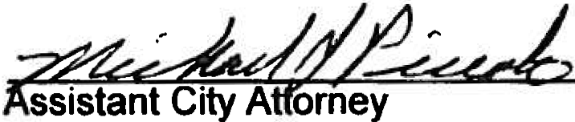Approved as to form:

2

